Node-RED supplies an exec node, which can be used to call external commands.

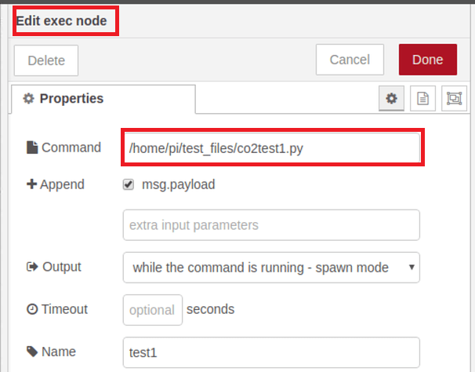

You can call a Python script with arguments with the exec node command:

python ~/script.py arg1 arg2

in your Python script you can catch the arguments with the sys module:

import sys

var1 = sys.argv[1]

var2 = sys.argv[2]

sys.argv[0] is reserved for the script name.